12.63: One can solve this problem using energy conservation, units of J/kg for energy, and basic concepts of orbits.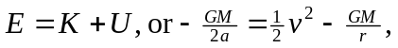where 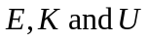 are the energies per unit mass, is the circular orbital velocity of 1655 m/s at the lunicentric distance of 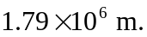 The total energy at this distance is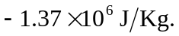 When the velocity of the spacecraft is reduced by 20 m/s, the total energy becomes

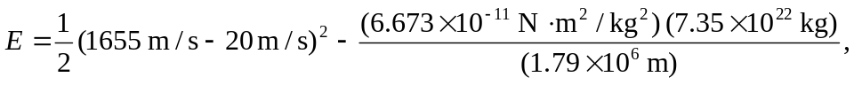

or 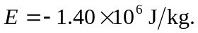 Since 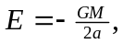 we can solve for 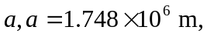the semi –major axis of the new elliptical orbit. The old distance of 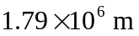 is now the apolune distance, and the perilune can be found from 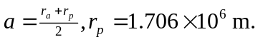Obviously this is less than the radius of the moon, so the spacecraft crashes! At the surface, 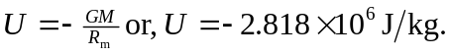
Since the total energy at the surface is 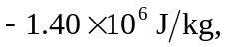the kinetic energy at the surface is

